

Response to the Henry Dimbleby Food Strategy Consultation

Introduction: the need to move from an agricultural policy to a food policy.

The pre-possession with agriculture at the expense of food in policy in the UK needs to be redressed. Agricultural policy has been found wanting in terms of cost, and failure to meet objectives.

Direct Payments to farmers in 2018 were £2.75 billion and Environmental and LFA Payments an extra, £500 million. Red Diesel Tax relief to farmers was around £500 million, Business Rate Relief around £1 billion and Inheritance Tax exemptions estimated at between £500 and £700 million. Only environmental payments (£436 million) explicitly address non-market externalities.

Well over £5 billion of State aid in 2018 supports a ‘high input’ agriculture that has failed to meet environmental and food security policy objectives and has had a range of detrimental economic impacts.

Environment
- Chemicals: high input agriculture has led to resource depletion (soils and water), high levels of chemical pollution, detrimental land use change, price volatilities and significant greenhouse gas emissions (particularly from animal agriculture). The latter must be reduced by 70% from the UK food chain by 2050 to meet binding international obligations.
- Biodiversity loss: despite considerable farm payments for environmental goods and services, species and numbers of birds and butterflies continue to fall, and three quarters of more than 200 ‘priority’ species (hedgehogs, door mice, moths) are down in number.

Food security
- Despite farm support, the UK imports around 40% of its food (and exports food to about half the value of imports).
- Farm support has been shown to stifle innovation and encourage intensification. It cushions the need for farmers to be market responsive. Relative to demand, there is under-provision of most salad and vegetables.
- Around a third of all food produced is lost or wasted each year (and 50% of the world’s fruit and vegetable production). Globally, this is equivalent to 1% of the output of everything.

Economics
- UK farm support is greater than the total income from farming (by £300 million): agriculture is economically inefficient.
- Farm support is inequitable in agriculture and in the nation. Basic Payments relate not to the amount of food produced but the amount of land managed. The largest (richest) owners and managers get the most.
- Food is more expensive as a result of farm support, but the consumer pays a second time, as the taxpayer who funds them.
- Because farm support is tied to land, it pushes up land prices beyond the reach of new entrants. The farm population ages and the rich buy the land for its investment value. Business Rate Relief and Inheritance Tax exemptions exacerbate this.

Whilst this situation needs change with some urgency, it is recognised that such change will cause disruption in the conventional farm sector and this will require considerable structural adjustment support (but this must be time limited).

The environmental and health problems caused by our food system

Whilst those environmental and health problems attributable to current agricultural practice have been noted above, the core to ameliorating them is to consider them as non-market externalities. The current Gove proposals for agricultural policy reform consider only biodiversity externalities. Within the food system as a whole, in contrast, there are at least seven externalities that need to be accommodated within any food strategy. We have not provided lengthy justifications of these here as they are widely known. Broadly, two fall at the production end of the food system, two at the consumption end and three are pervasive of the whole system.

Production externalities | Whole System externalities | Consumption externalities
Biodiversity | Food Miles | Obesity
Chemical Pollution | Food Waste | Food Poverty
 | Food Education

Externalities are commonly dealt with in policy through either taxation (to reduce negative externalities) or support (to encourage positive externalities). In the diagram below we represent a possible regime of taxes (in blue) and support (in green) for different externalities the whole food system.

Externality | Bio-diversity | Chemical Pollution | Food Miles | Food Waste | Food Education | Obesity | Food Poverty
Tax

Support

It is quite possible that this approach to accommodating externalities of the whole food system into policy could be cost neutral (additional support is covered by additional taxation) but certainly is likely to have a net cost much lower than the current £5 billion of farm support.

Measures to ensure the security of our food supply,

A number of these address the problems of current agricultural policy noted above. Some improvements in food security are likely to accrue, however, simply by moving away form current forms of support.

- Food, in policy, should be re-characterised as a basic societal need and not just as a market commodity.
- All stages of the food system (see below) should be embraced in policy.

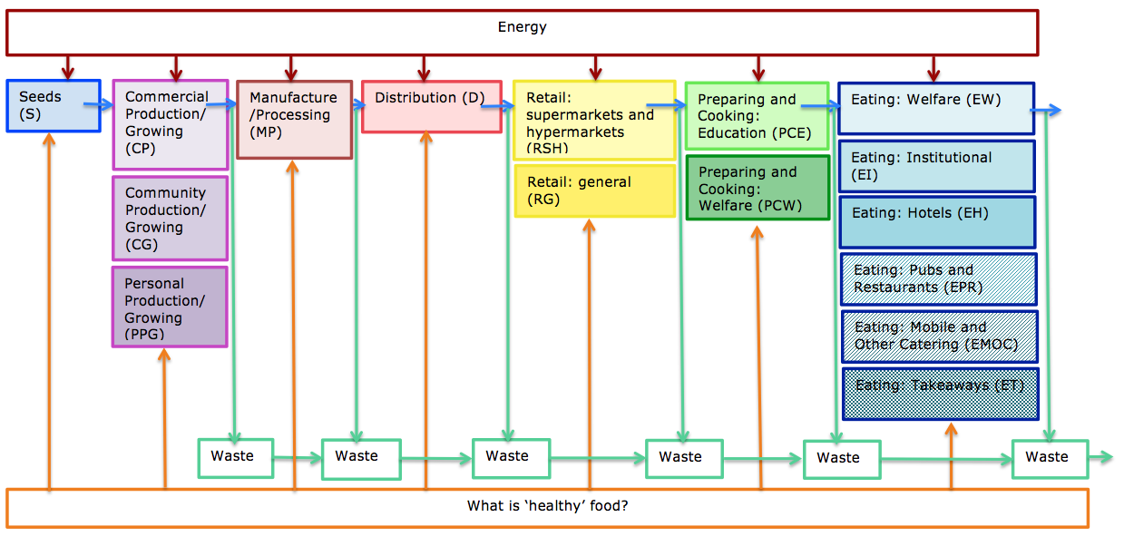

- Considered in its social (rather than just is market) context, food has multiple benefits. Many growing projects, for example, tackle physical and mental heath and drug addition. Local processing can create jobs and positive local multipliers. ‘Social’ consumption can create community cohesion. Education around food can improve cooking skills and lifestyle changes and can tackle obesity). And all aspects of the food system can be used to tackle environmental issues (reducing food waste and food miles). All of these multiple benefits should be embraced in policy.
- The base of production should be broadened. Community production, urban farming, warehouse and underground production, aquaponics and hydroponics all will add to food output, but importantly also will engage a broader base of the population, reconnecting people with food and educating people about food. Output per unit of input has been shown to be much higher in community agriculture than in commercial agriculture.
- Introduce food growing requirements into planning conditions for new housing. This has been show to be successful in a number of paces (for example Brighton).
- Educate about all aspects of food consumption as an essential part of the food curriculum. Understanding seasonality in consumption, for example, offers the potential to change consumption patterns drastically.
- Give policy priority to food production for home consumption rather than for export, to reduce food miles and to be more self-sufficient.
- Drastically reduce the production of animal agriculture and move towards plant-based production. This is a much more efficient (and much les wasteful) means of feeding the nation.
- Where animal agriculture is tolerated, priority should be give to small mixed farms with balanced local ecosystems.
- Where plant-based production is not possible because of the poor quality of land, the land should be turned over to forestry rather than livestock grazing, for carbon sequestration.

And to maximise the benefits of the coming revolution in agricultural technology.

Technical innovation in agriculture has the potential to modify food production beneficially but, we argue, it is social innovation (and particularly education) that is needed to change food attitudes, understandings and consumption patterns. We therefore council against technical innovation being seen as a panacea in food policy because it gain runs the risk of pushing food policy back to being dominantly agricultural policy. Technical innovation could therefore further disconnect people form food. In this context we note the following.

- Current UK agriculture is over-capitalised in terms of the value of output per unit of capital input. Capitalisation has arisen as a result of state aid rather than market rationale.
- The ‘current revolution’ in agricultural technology is driven more by the need to counteract Brexit farm labour shortages than by economic efficiency.
- Labour shortages in longer structural terms could also be address by reforms to planning policies that make it easier for lower income people to live in rural areas –toe the extent that they remain the principal theatre for food production.
- Exploit the potential of ‘technological innovation’ away from land based food production (underground, warehouse growing, aquaponics etc.) as close as possible to the point of consumption.
- Explore fully the potential of intermediate technologies, and historical traditions in all aspects of the food chain, as well as ‘modern’ innovation.
- Exploit technologies that can yield the multiple benefits from food production noted above.

Postscript

None of the proposals set out above is asserted as a direct replacement of current food system characteristics, certainly in the short term. They are innovations that need to be supported and monitored and evaluated in an experimental way at the same time as the necessary structural adjustments in agriculture to move away from high input, high animal farming.

All data in this document are from government sources (principally Defra)

